**Institute of Engineering & Management**

**Department of Computer Science & Engineering**

**Network Lab for 3rd year 6th semester 2019**

**Code: CS 692**

**Date:** 04/02/19

**WEEK-1**

**Assignment-1**

**Problem Statement:** Configure a Router

**CLI code:**

Router>en

Router#config terminal

Enter configuration commands, one per line. End with CNTL/Z.

Router(config)#interface fastEthernet 0/0

Router(config-if)#ip address 192.168.10.1 255.255.255.0

Router(config-if)#no shutdown

Router(config-if)#

%LINK-5-CHANGED: Interface FastEthernet0/0, changed state to up

%LINEPROTO-5-UPDOWN: Line protocol on Interface FastEthernet0/0, changed state to up

Router(config)#exit

Router#

%SYS-5-CONFIG_I: Configured from console by console

Router#copy running-config startup-config

Destination filename [startup-config]?

Building configuration...

[OK]

Router#

**Screen-Shot:**

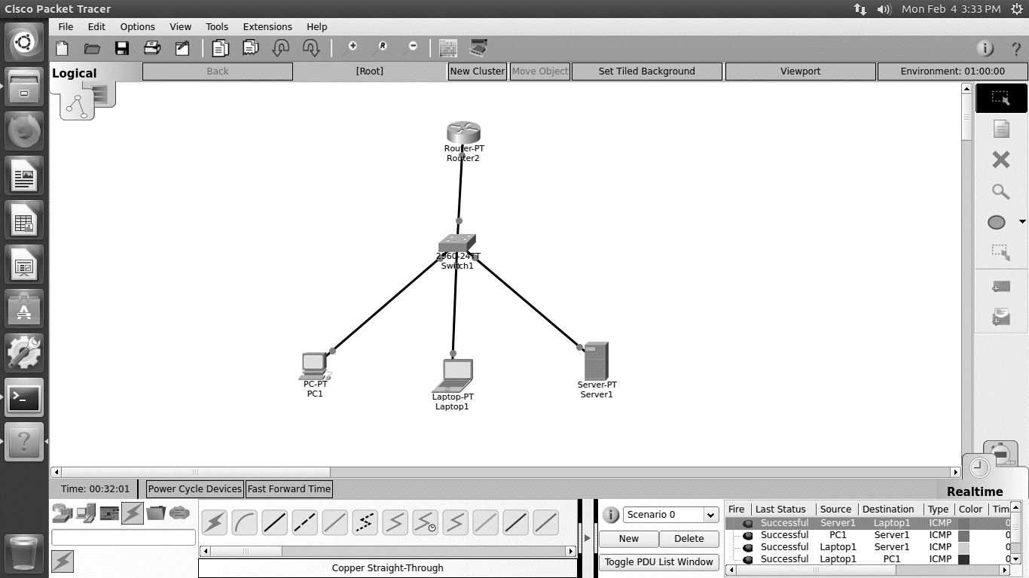

**Assignment-2**

**Problem Statement:** Configure two Routers and connect them both with serial port.

**CLI code:**

**Router-1:**

Router>en

Router#config terminal

Enter configuration commands, one per line. End with CNTL/Z.

Router(config)#interface gigabitEthernet 0/0

Router(config-if)#ip address 192.168.10.1 255.255.255.0

Router(config-if)#no shutdown

Router(config-if)#

%LINK-5-CHANGED: Interface GigabitEthernet0/0, changed state to up

%LINEPROTO-5-UPDOWN: Line protocol on Interface GigabitEthernet0/0, changed state to up

Router(config-if)#exit

Router(config)#interface serial 0/1/0

Router(config-if)#ip address 10.0.0.1 255.0.0.0

Router(config-if)#clock rate 64000

Router(config-if)#no shutdown

Router(config-if)#

%LINK-5-CHANGED: Interface Serial0/1/0, changed state to up

%LINEPROTO-5-UPDOWN: Line protocol on Interface Serial0/1/0, changed state to up

Router(config-if)#ip route 192.168.11.0 255.255.255.0 10.0.0.0

Router(config)#

**Router-2:**

Router>en

Router#config terminal

Enter configuration commands, one per line. End with CNTL/Z.

Router(config)#interface gigabitEthernet 0/0

Router(config-if)#ip address 192.168.11.1 255.255.255.0

Router(config-if)#no shutdown

Router(config-if)#

%LINK-5-CHANGED: Interface GigabitEthernet0/0, changed state to up

%LINEPROTO-5-UPDOWN: Line protocol on Interface GigabitEthernet0/0, changed state to up

Router(config-if)#exit

Router(config)#interface serial 0/1/0

Router(config-if)#ip address 10.0.0.2 255.0.0.0

Router(config-if)#no shutdown

Router(config-if)#

%LINK-5-CHANGED: Interface Serial0/1/0, changed state to up

%LINEPROTO-5-UPDOWN: Line protocol on Interface Serial0/1/0, changed state to up

Router(config-if)#ip route 192.168.10.0 255.255.255.0 10.0.0.0

Router(config)#

**Screen-Shot:**

